Title
  - Author¹, Another Author² and Another Author³
¹Affiliation1
²Affiliation2
³Affiliation3
(Received: DD. Month YYYY, Accepted: DD. Month YYYY, Published online: DD. Month YYYY)
Here comes the abstract. © G-Labs YYYY
(Here comes the DOI)
corresponding.author@example.com

- Introduction
Here comes the introduction. It should be concisely written and contain the most important previous work on the topic along with suitable references (not more than 25!) in the form [1], [2,3] or [4-6].
- 2nd Main Section
All sections should be labelled as this.
  - Subsection
If subsections are needed, they should appear in the form.
- Figures
Figures can either be included as a single column picture (Fig. 1) or as a picture that spans the whole page (Fig. 2).

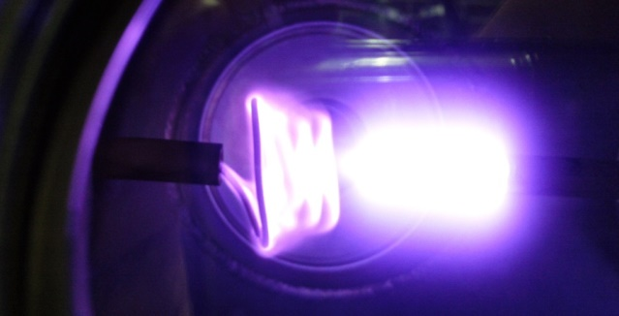
Figure 1: This is an example for a single column figure.

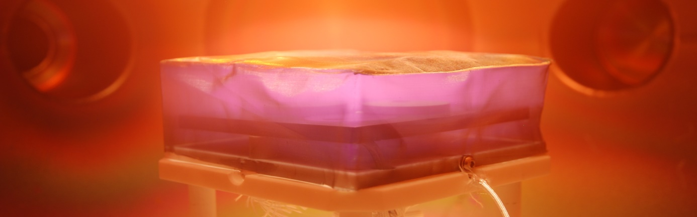
Figure 2: This is an example of a picture, which spans the whole page.

References to pictures within the manuscript should be labelled like this: Fig. 1, etc.

- Tables
Tables can occur in two different forms, just like figures: They can either be single (Table 1) or over the whole page (Table 2).
A reference to a table within the text should be done as Tab. 1, etc.

Column 1 | Column 2 | Column 3
Table 1: This is an example of a standard table.

Column 1 | Column 2 | Column 3 | Column 4 | Column 5
Table 2: This is an example of a table that spans the whole page.

- Equations
Equations should be centered within one column and labelled in the following manner:
$E=mc²$ (1)
References to formulas within the text should be abbreviated with Equ. (1), etc.
- References
References should contain the names of five co-authors maximum, for more than five co-authors, the abbreviation et al. should be used.
[1] J. Gruenwald, A. Einstein, and J. Doe, “A guide for writing for the JTSP,” J. of Technol. and Space Plasmas, vol. 0, no. 1, 2018.

Open Access. This article is licensed under a Creative Commons Attribution 4.0 International License, which permits use, sharing, adaptation, distribution and reproduction in any medium or format, as long as you give appropriate credit to the original author(s) and the source, provide a link to the Creative Commons license, and indicate if changes were made. The images or other third party material in this article are included in the article s Creative Commons license, unless indicated otherwise in a credit line to the material. If material is not included in the article’s Creative Commons license and your intended use is not permitted by statutory regulation or exceeds the permitted use, you will need to obtain permission directly from the copyright holder. To view a copy of this license, visit: http://creativecommons.org/licenses/by/4.0/.

